Course Title: AI Assisted Coding
Course Code: 23CS002PC304
Faculty Name: Dr. R. Prashant Kumar
Name: P. Ashwitha
HT no: 2303A52420- Batch(36)
Question:
Lab 1: Environment Setup – GitHub Copilot and VS Code Integration + Understanding AI-assisted Coding Workflow
Task 0:
- Install and configure GitHub Copilot in VS Code. Take screenshots of each step.
Step 1: Open Visual Studio Code
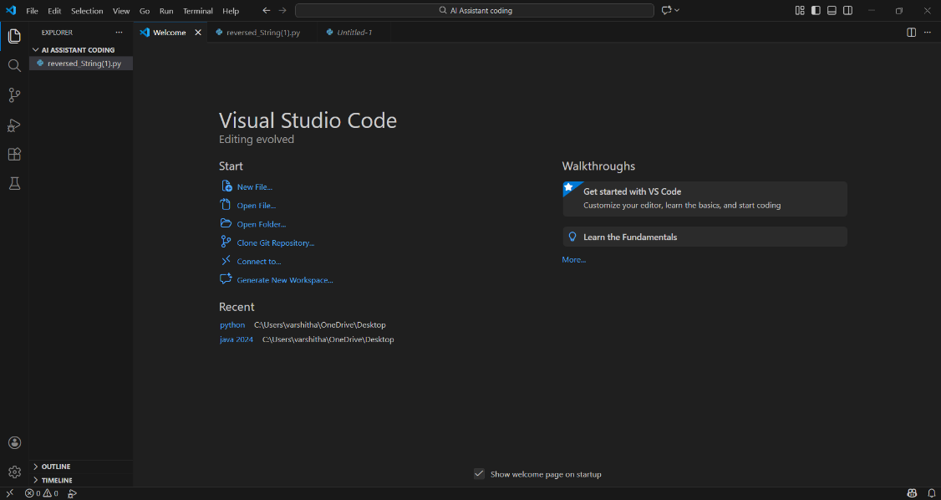
Step 2: Open Extensions Panel
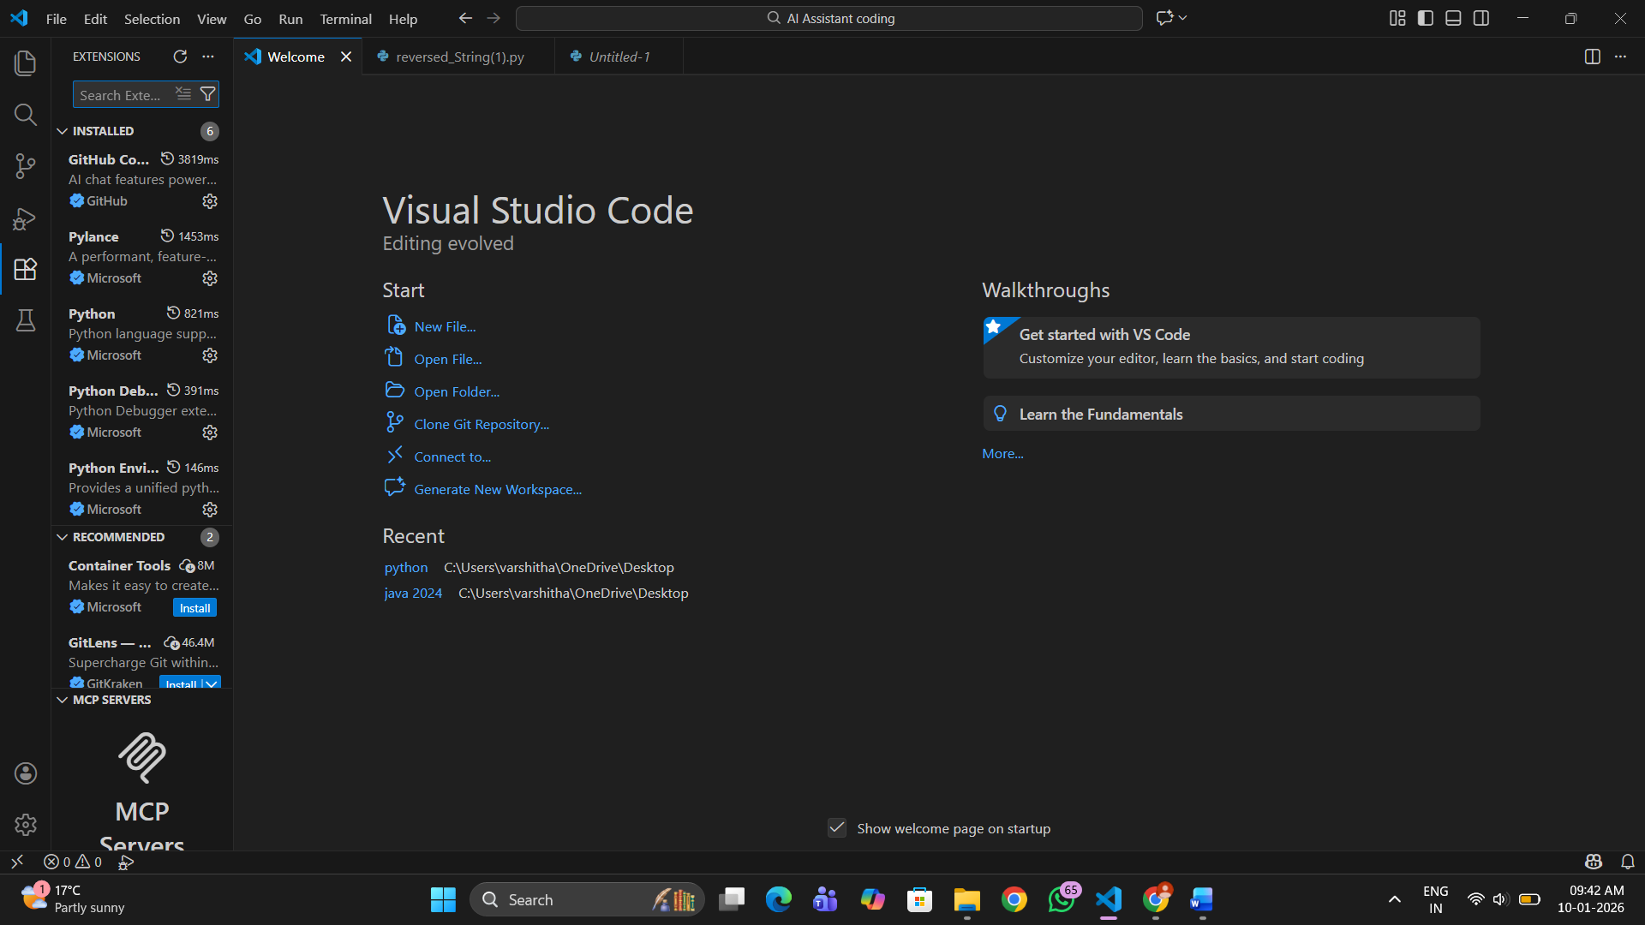
Step 3: Search for GitHub Copilot
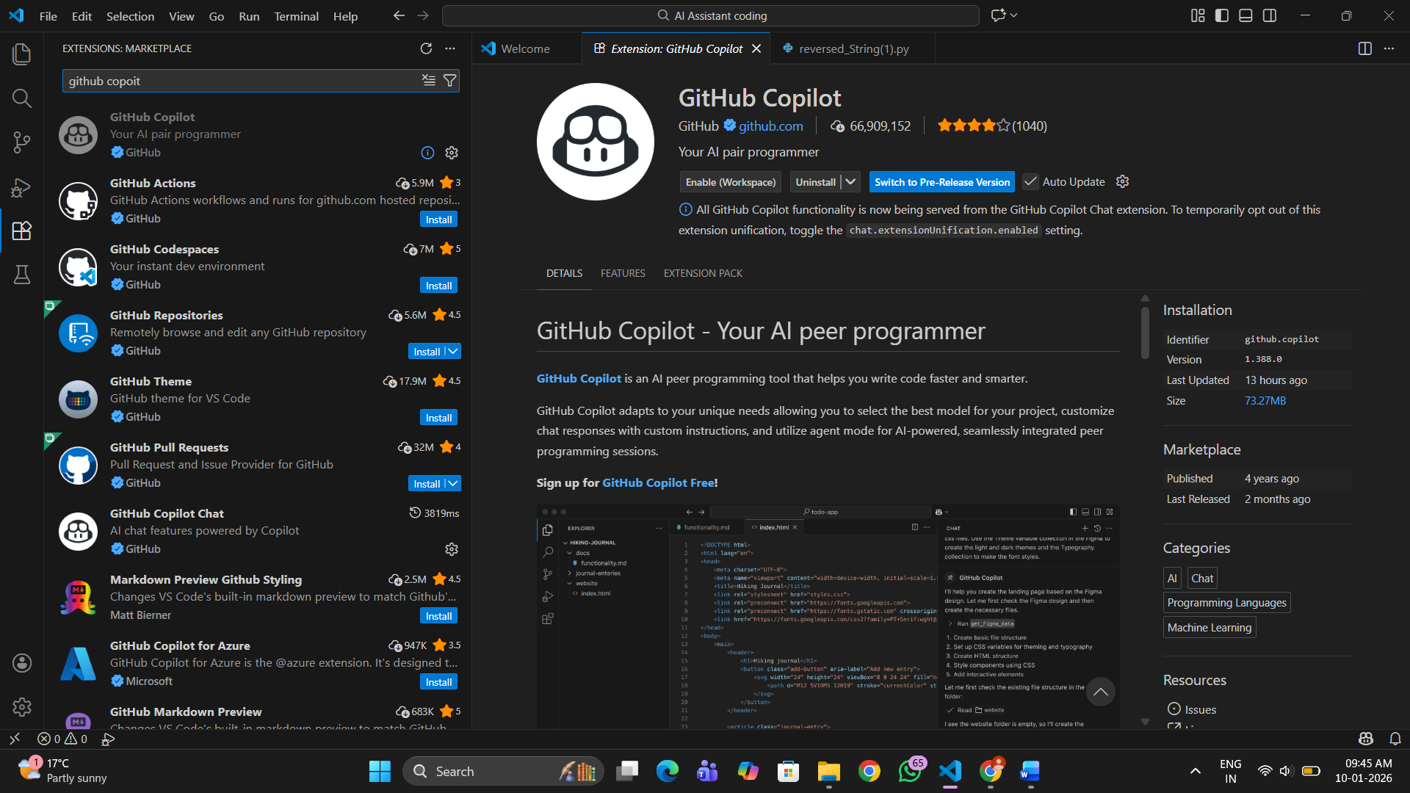
Step 4: Install GitHub Copilot
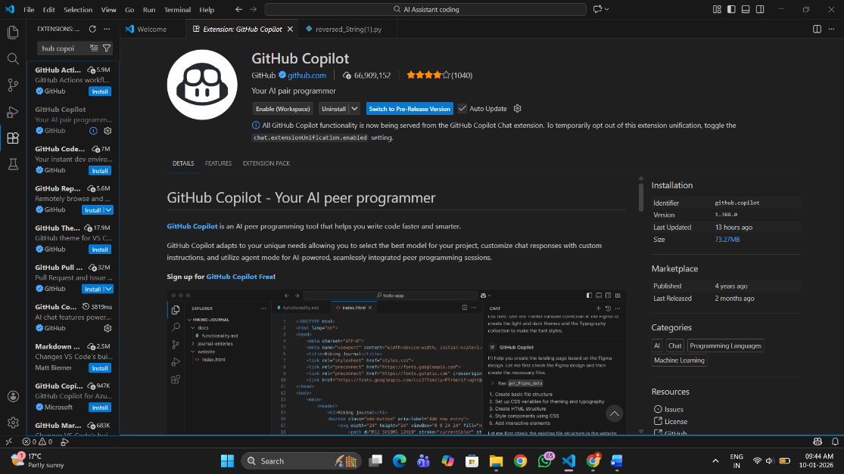
Step 5: Sign in to GitHub Account
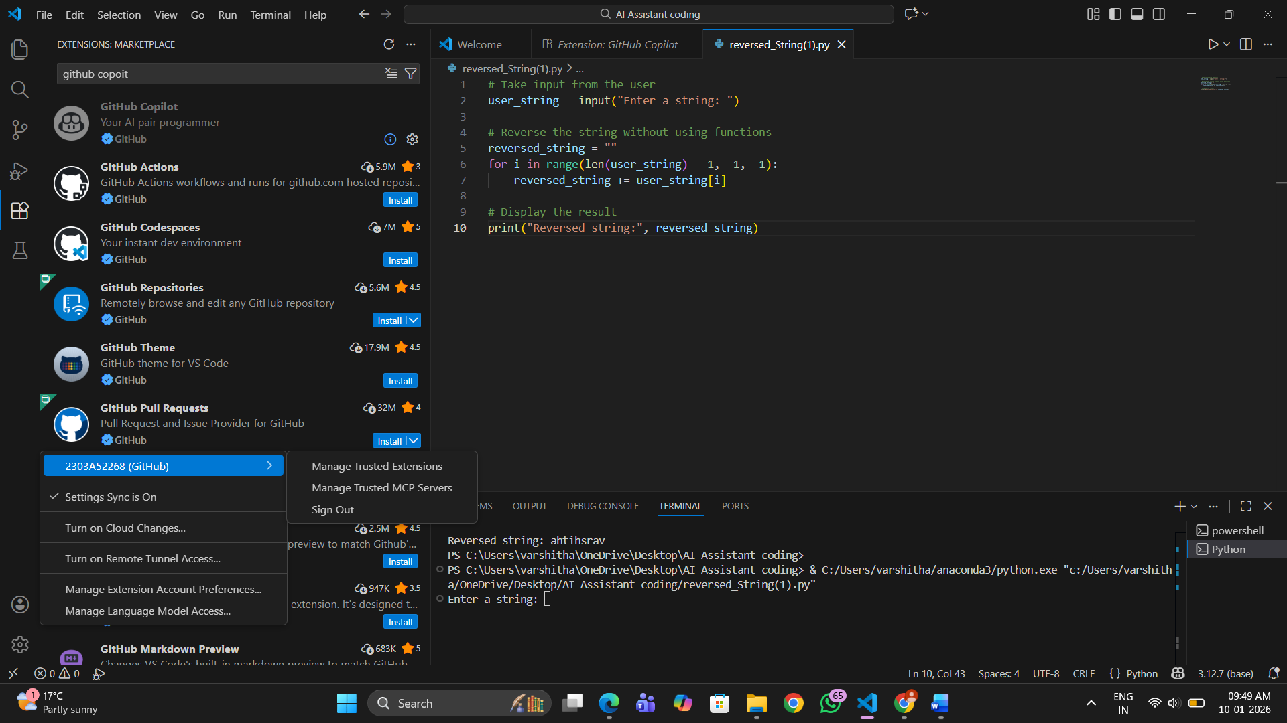
Step 6: Authorize GitHub Copilot
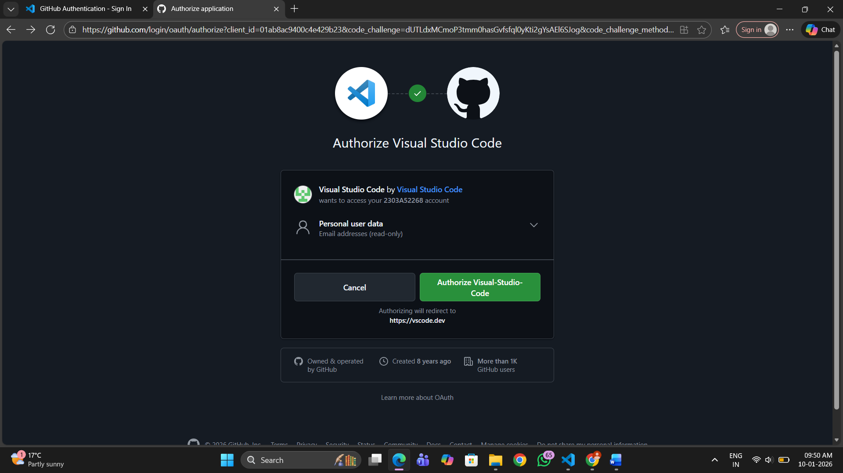
Step 7: Verify Copilot is Enabled
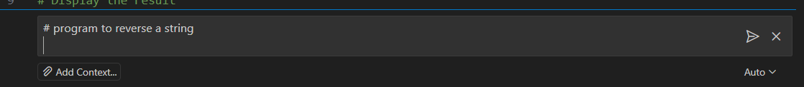
Task 1: AI-Generated Logic Without Modularization (String Reversal Without
Functions)
# program to reverse a string
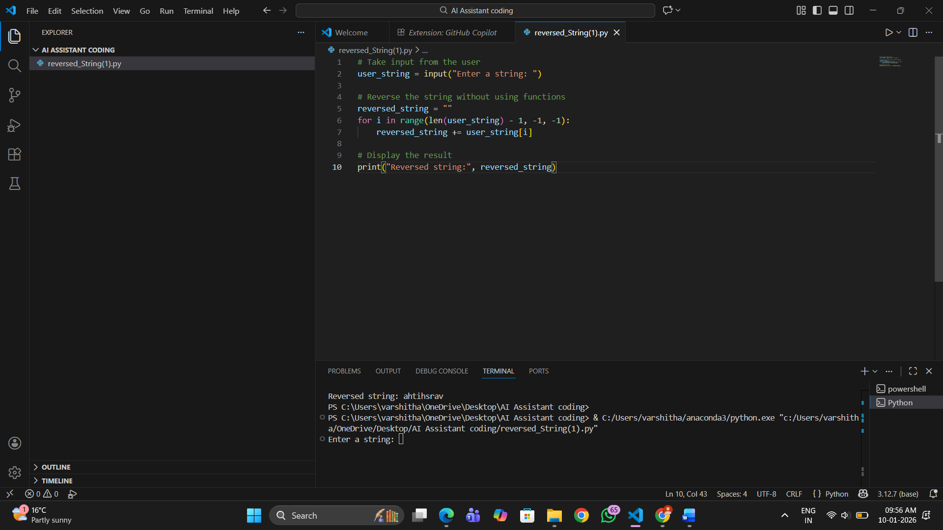
Output: 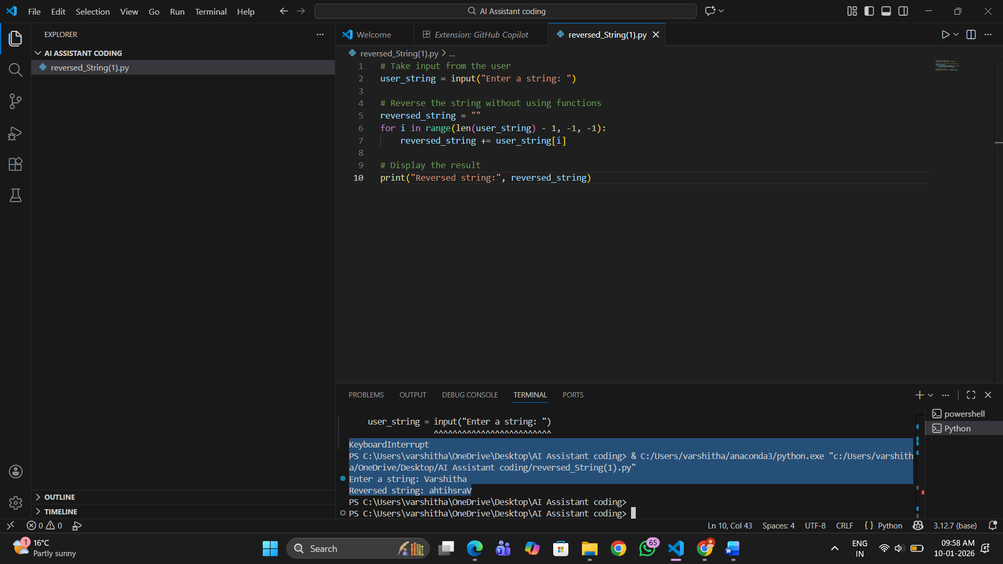
Explanation
- The input() function takes a string from the user.
- An empty string rev is created to store the reversed result.
- The for loop iterates through the string from the last character to the first.
- Each character is appended to rev.
- The final reversed string is printed.
- The logic is written directly in the main code without using functions

Task 2: Efficiency & Logic Optimization (Readability Improvement)
# Simplified String Reversal Code
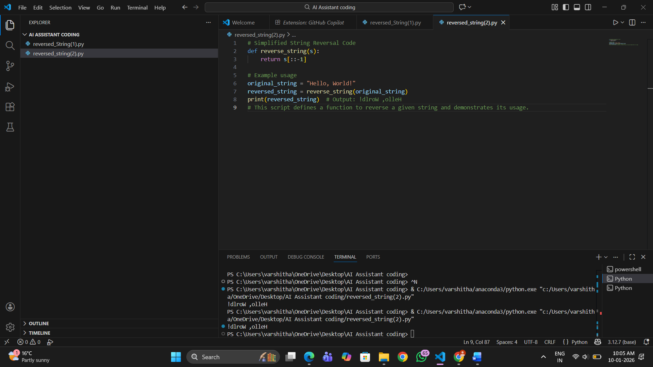
Output:

Explanation of Optimization
- The loop and extra variable were removed
- Python slicing reverses the string in a single step
- Code is shorter, cleaner, and easier to understand
Time Complexity Explanation
- Original code: O(n) (manual loop)
- Optimized code: O(n) (built-in slicing)
- Although complexity remains the same, slicing is faster in practice due to internal optimization

Task 3: Modular Design Using AI Assistance (String Reversal Using Functions)
# Write a Python function to reverse a string
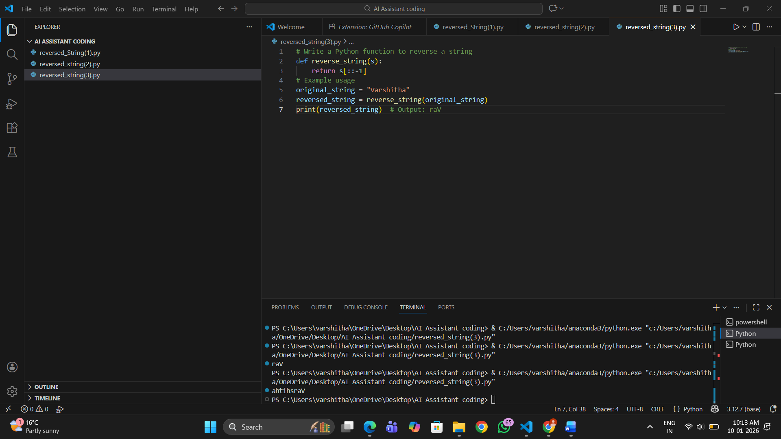
Output: 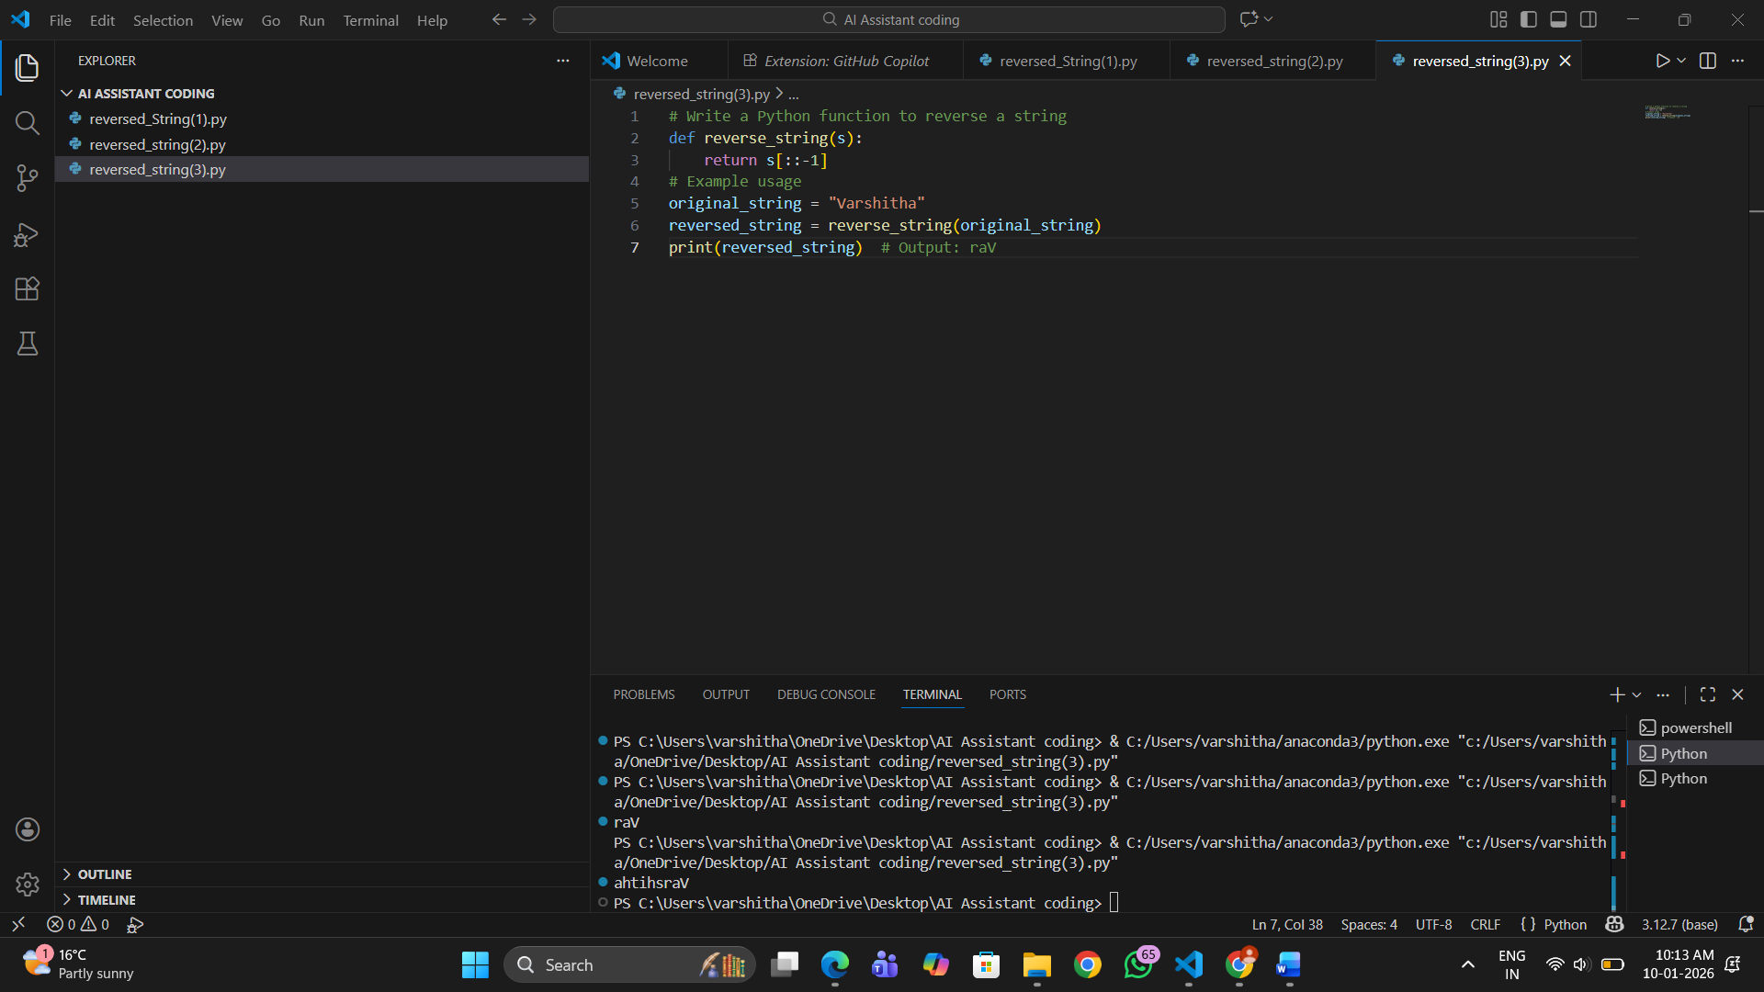
Explanation
- A function reverse_string() is defined to reverse a string.
- The function takes one parameter text.
- The slicing method [::-1] is used to reverse the string.
- The reversed string is returned to the caller.
- User input is passed to the function.
- The result is printed.
- This modular approach improves reusability and readability.

Task 4: Comparative Analysis – Procedural vs Modular Approach (With vs
Without Functions)

Aspect | Without Function (Procedural) | With Function (Modular)
Code Clarity | Moderate | High
Reusability | Not reusable | Highly reusable
Debugging | Difficult | Easier
Maintainability | Low | High
Large-scale Suitability | Poor | Good

Task 5: AI-Generated Iterative vs Recursive Fibonacci Approaches (Different
Algorithmic Approaches to String Reversal)
#Generate a loop based string reversal program in Python
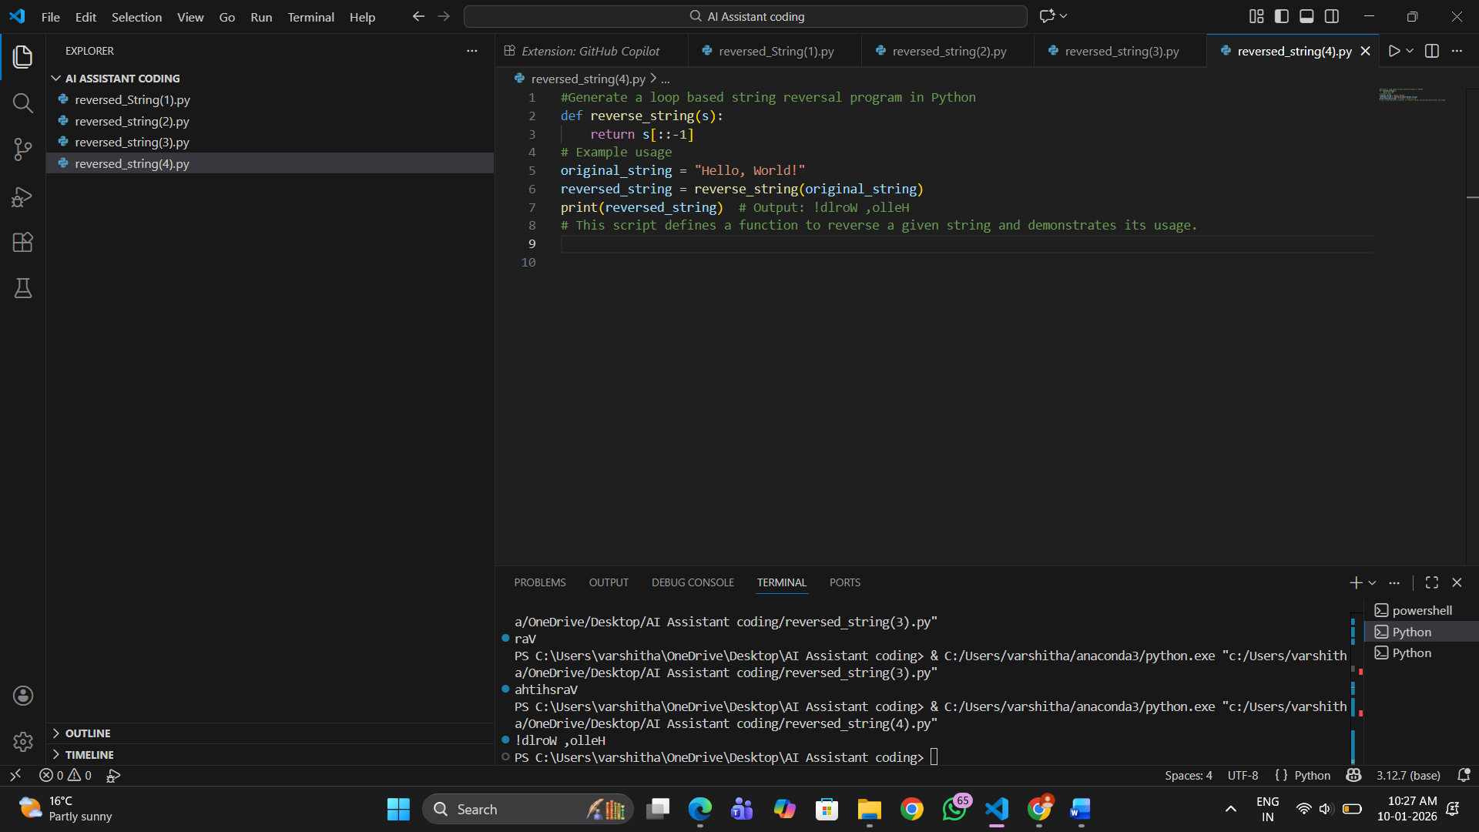
Output: 
Explanation
- The user inputs a string.
- An empty string rev is created.
- The loop reads each character from left to right.
- Each character is added at the beginning of rev, reversing the order.
- The reversed string is printed.
- This method helps understand string manipulation logic.

#Generate a slicing based string reversal program in Python
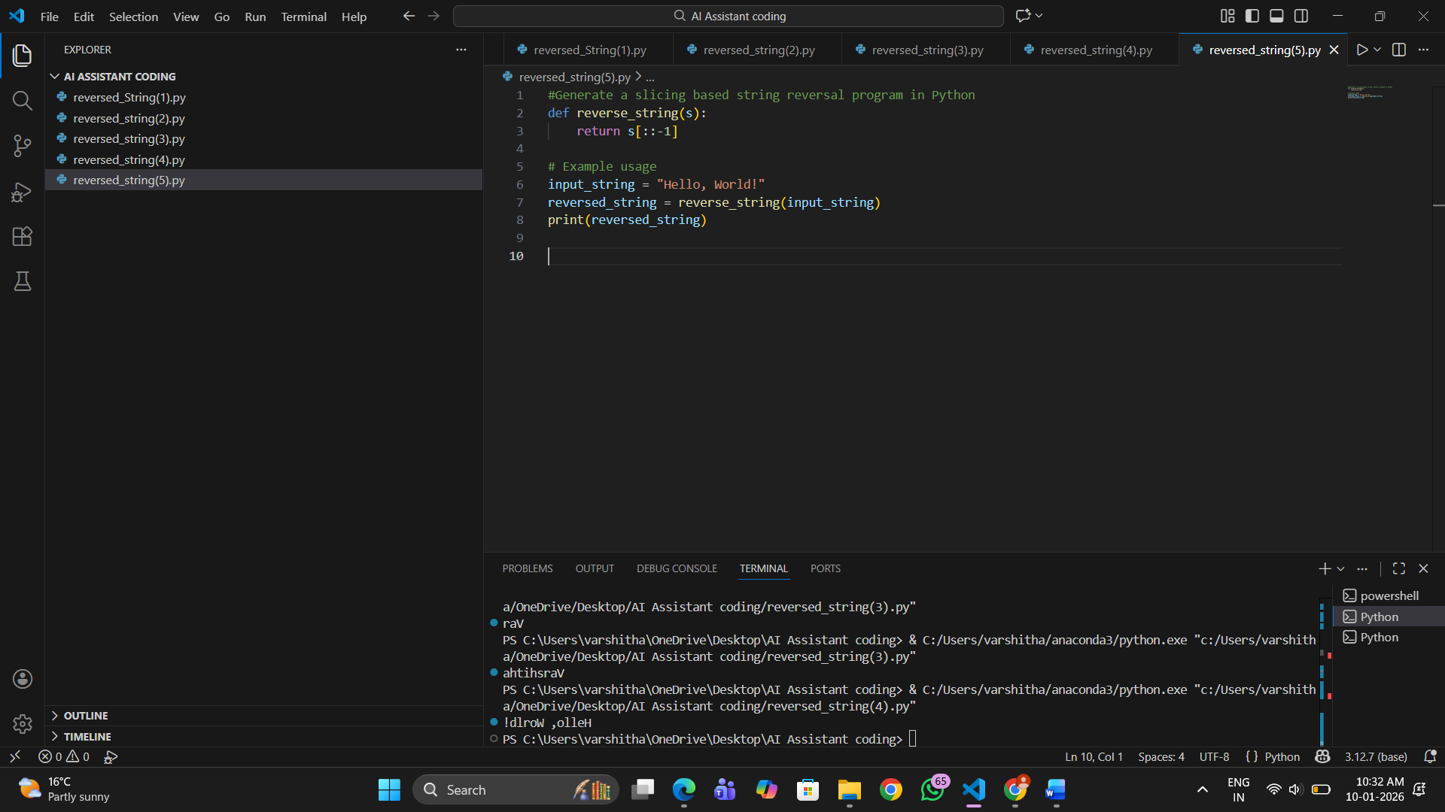
Output: 
Explanation
- The string is taken from the user.
- Python slicing reverses the string efficiently.
- The reversed string is printed directly.
- This approach is best for large inputs and real-world applications.
Comparison of Approaches
Aspect | Loop-Based | Slicing-Based
Execution Flow | Step-by-step reversal | Single operation
Time Complexity | O(n) | O(n)
Performance for Large Inputs | Slower | Faster
Readability | Moderate | Very High
Best Usage | Learning logic | Production code

